SYSTEM & MAINTENANCE MANUAL
FOR
MANUAL SWING GATE

CLIENT: TATA PROJECT LTD
PROJECT: ALSTOM
MFG.YEAR: -

DESIGNED, DEVELOPED & MARKETED
BY



G-BLOCK, 1ST FLOOR, THERMAX CHOWK
MIDC, ABOVE RENAULT SHOWROOM
CHINCHWAD, PUNE-411019

TEL.NO: - +912066304033
EMAIL:-info@nihva.com
www.nihva.com

AUTOMATIC SLIDING GATE
SIZE | 9.5 X 1.8
SR NO
CLIENT | TATA PROJECT LTD

ABTRACT:

We are pleased to forward this manual to you to provide guidelines on trouble free operation of the equipment, procedures for periodic and preventive maintenance, and troubleshooting. This manual consists of the description of equipment along with technical specifications, and operation procedures. For maintenance of ‘Bought-out’ equipment, please refer manufacturers’ manuals. We insist you to maintain necessary record (logbook) for ensuring proper preventive maintenance, to achieve trouble free production. We are sure; you will find this manual very useful and interesting. However, your suggestions and doubts if any are always welcome!

CONTENTS

- OPERATING & SAFETY INSTRUCTION

- GA DRAWING – WICKET GATE

- GA DRAWING – AUTOMATIC SLIDING GATE

- SPARE & WEAR PART LIST

OPERATING & SAFETY INSTRUCTIONS FOR
TELESCOPIC/SLIDING GATE

It is important to make sure everyone that will be using the gate is aware of the following dangers associated with automatic Gates
- Always keep track of the gate clean i.e. dust &Mud free for smooth operation of gate & long life of wheels.
- Do not contact any part of the gate or walk in the path of the gate while it is moving. Never let children play with the gate controls. Do not attempt to “beat the gate” while it is closing. This is extremely dangerous.
- Ensure proper working of wheels of gate otherwise get it replaced from manufacturer.
- Please ensure proper alignment of track if there is any noise then contact to the supplier.

GA DRAWING: MANUAL SWING GATE

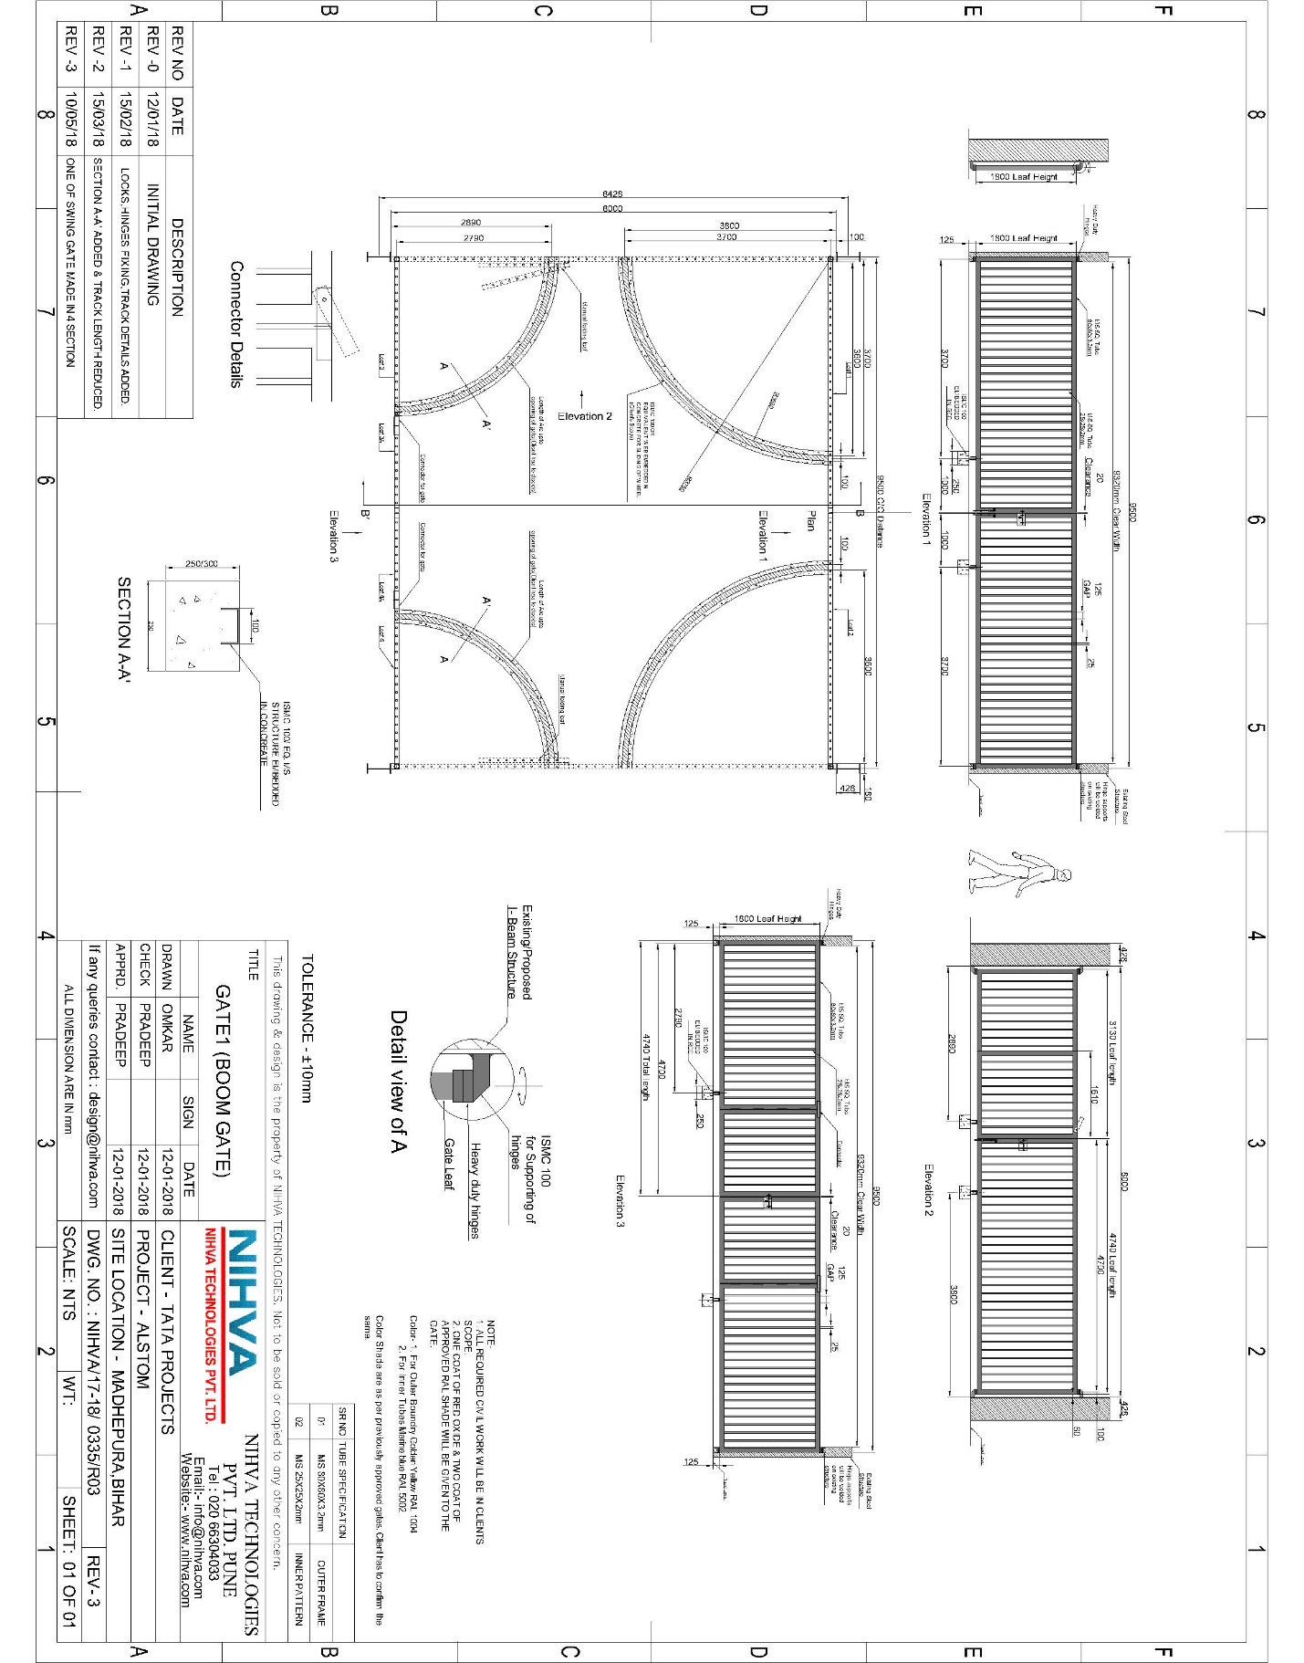

SPARE & WEAR PART LISTS:

S NO | ITEM DESCRIPTION | QTY.
1 | HINGES | 4
2 | GATE M.S WHEEL | 2

